Description of the Product
40 HP ELECTRIC OUTBOARD MOTOR

SEAGÖ SE40 series is an electric outboard motor has a rated voltage of 144V, and the maximum power is 29.4 kW. Compared to the existing gasoline models, the electric outboard is quieter and more environmentally friendly because they run on electricity instead of fuel. Additionally, we use Permanent Magnet Synchronous Motors, which have reduced noise, extended lifespan, increased efficiency and require less maintenance.
Relevant Boat Class
Small vessels of various materials including inflatable boats, wooden boats, FRP boats, plastic boats and similar, with lengths ranging from 4 Metres above, are a good fit for the electric 40-horsepower outboard motor.
Recommended Battery
For this Model, 144V 200 AH LiFePO4 – Lithium Ferrous Phosphate battery packs can be utilized
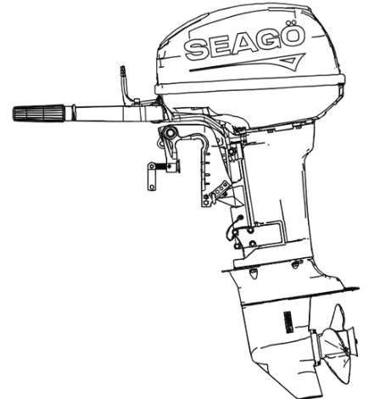
Model Options
SE40A0(All in one) – Short/Medium/Long
Adjustable transom Height

Specifications

Product Model | SE40AO
Rated Power | 29.4 kW
Rated Voltage | 144 V
Motor Type | PMSM
Sensor Type | Magnetic Encoder
Control System | Steering Grip - Steering Wheel Controls
Maximum Speed | 5000-6000 RPM
Gear Ratio | 2.0
Transom Height | 508mm(max)
Weight {Kg} | 89 Kg
Cooling System | Water Cooled
Gear Position | Forward /Neutral / Reverse

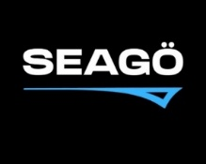
www.seago.in sales@seago.in +91-8606366633
40 HP ELECTRIC OUTBOARD MOTOR

